**ASSIGNMENT 18.1:**

**Problem Statement 1:**

Run a map only job on the word count program using static configurations.

**Program:**

**Driver Class:**

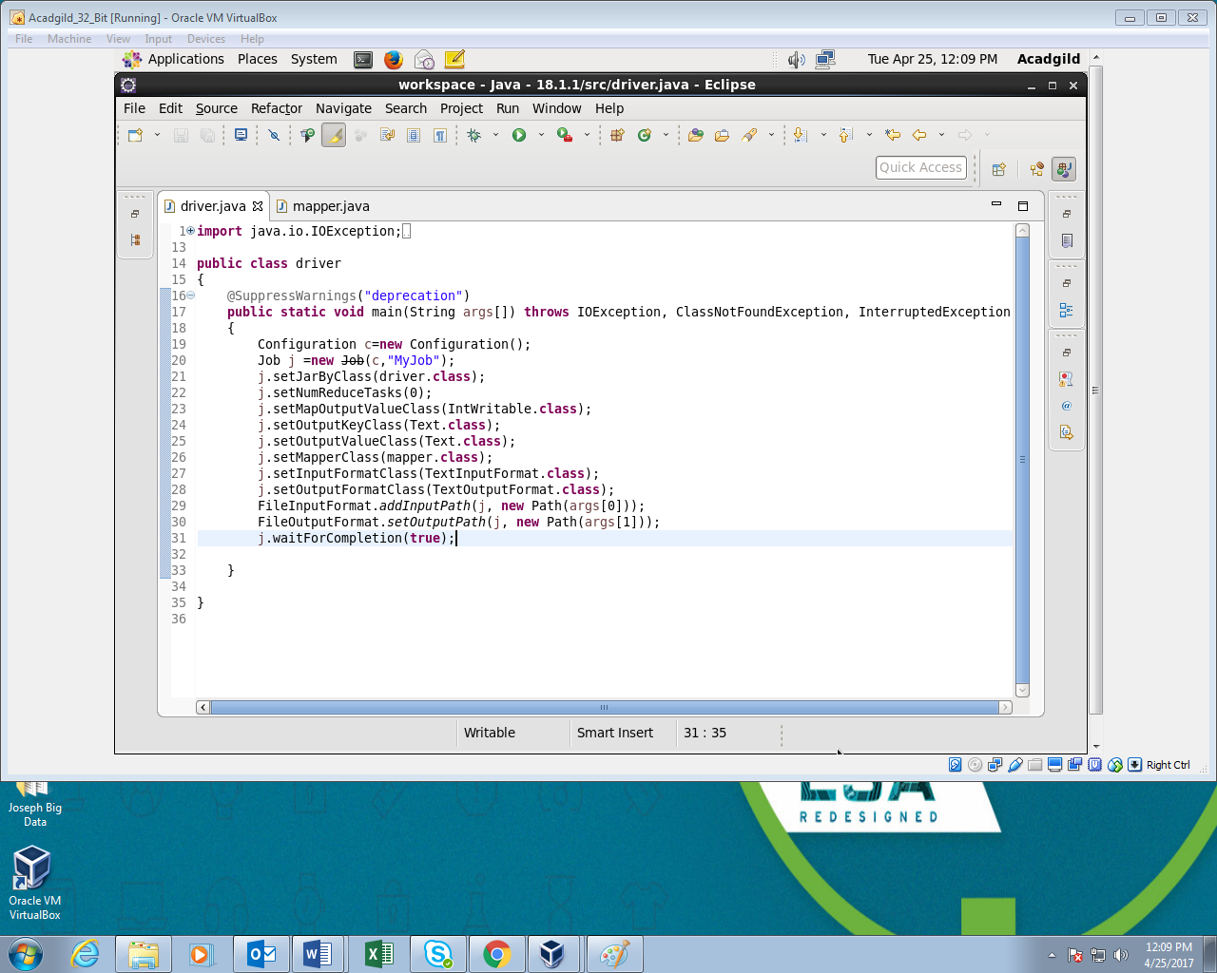

**Mapper Class:**

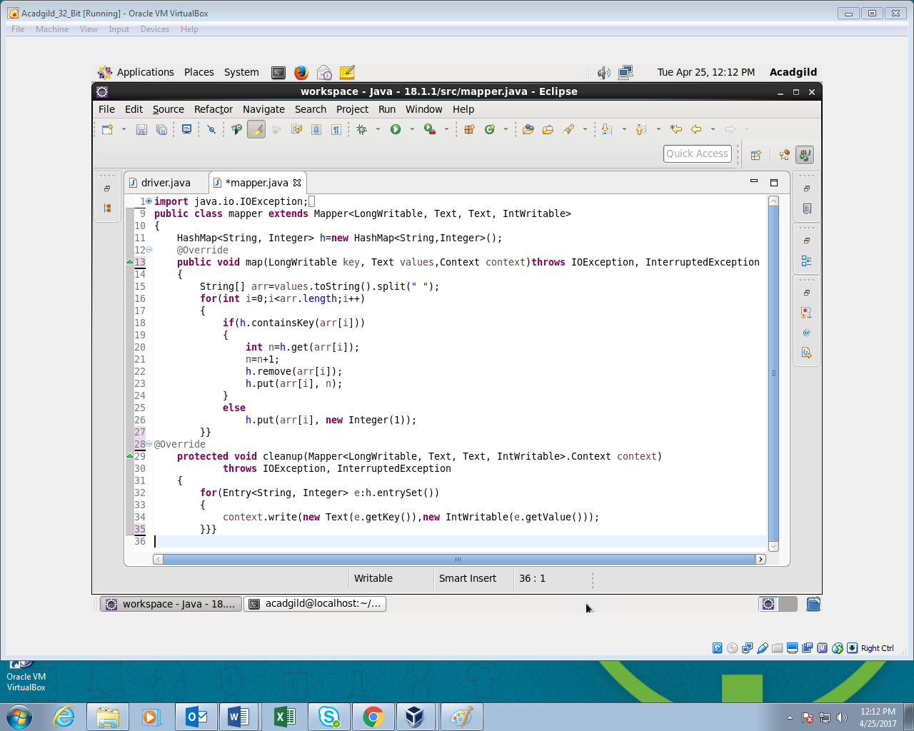

**Output:**

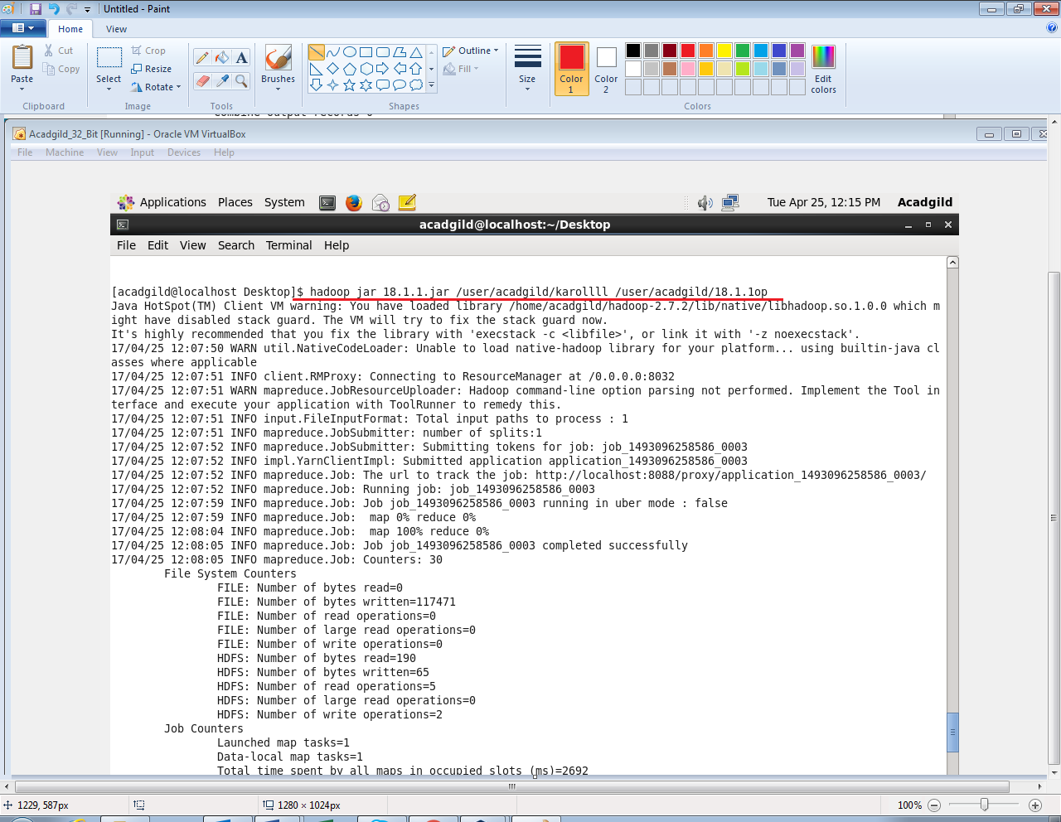

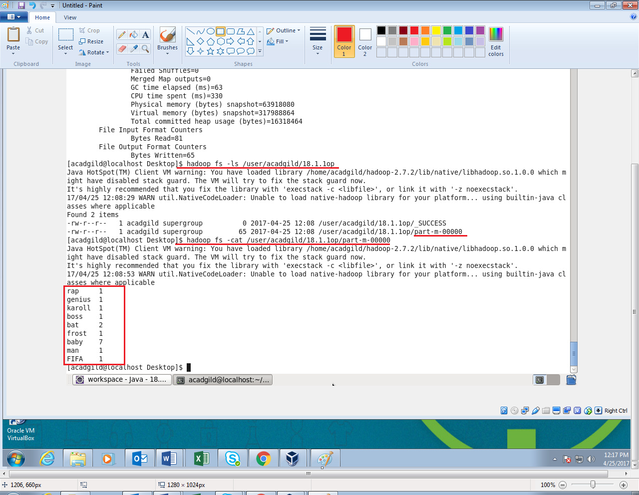

**Problem Statement 2:**

Run the mapreduce word count program and set the number of reducers to 2 using static configurations.

**Program:**

**Driver Class:**

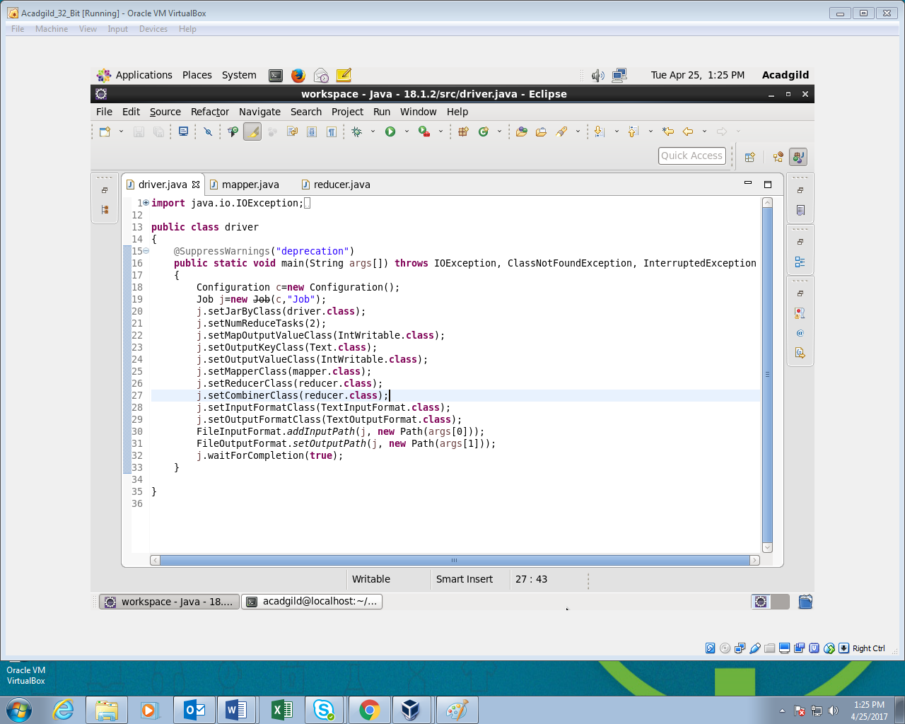

**Mapper Class:**

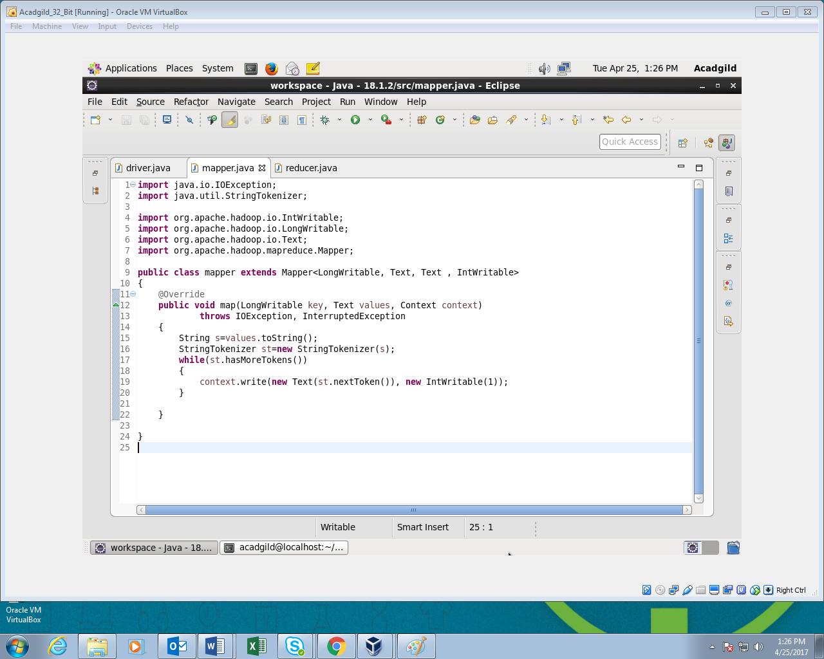

**Reducer Class:**

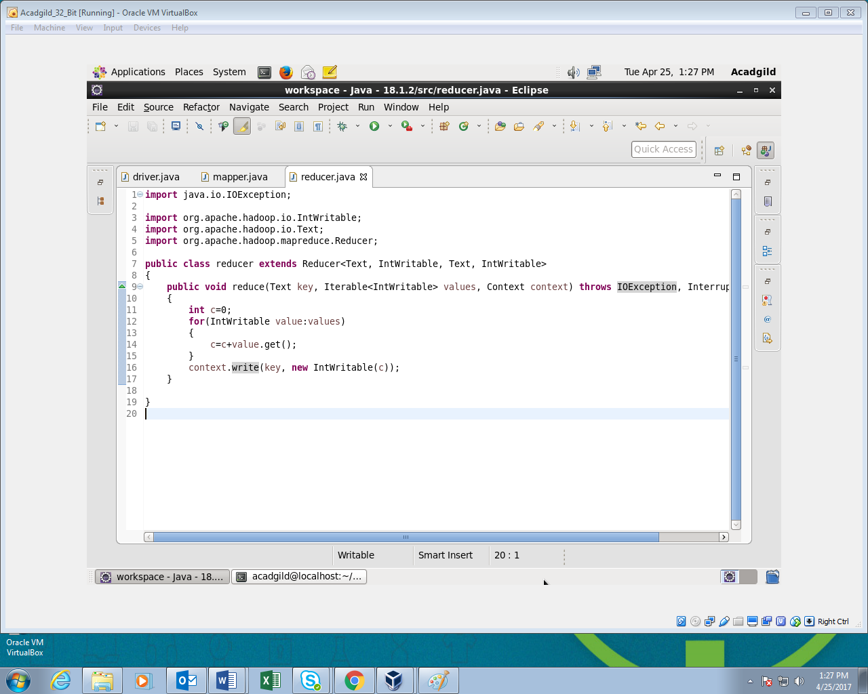

**Output:**

